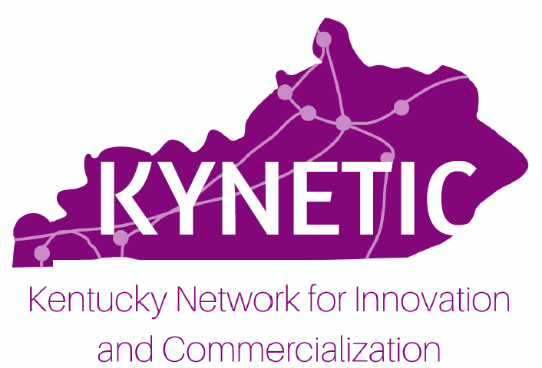 Non-Proprietary Abstract
KYNETIC Product Development Grant Pre-Application – Cycle #2

The non-proprietary abstract (maximum of 250 words) should be submitted as an editable Word document. The abstract may be shared with representatives from the industry, so please ensure that the abstract does not contain any proprietary information. If you have questions or need assistance composing your abstract, please contact Kendra Stenzel (kynetic@uky.edu).

Project Information

Project Title: Click here to enter text.

Abstract (max 250 words)
Click here to enter text.

